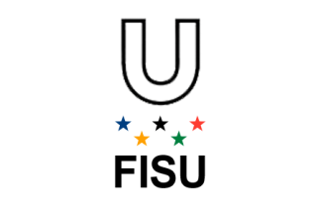  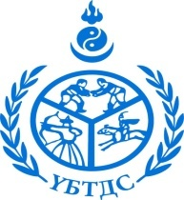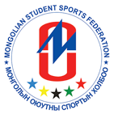

**Ministry of Education, Culture, Science and Sport**

**International University Sports Federation**

**International Association of Physical Education and Sport Universities**

**Mongolian National Institute of Physical Education**

**Mongolian Student Sports Federation**

**NEWSLETTER**

**VIII INTERNATIONAL CONFERENCE OF STUDENTS**

**AND YOUNG SCIENTISTS**

**«UNIVERSITY SPORT: HEALTH AND PROSPERITY OF A NATION»**

**Dear colleagues!**

On behalf of International Association of Physical Education and Sport Universities we are very delighted to invite students of different study levels to attend the International Conference of Students and Young Scientists “University Sport: Health and Prosperity of a Nation”. The Conference will host Mongolia National Institute of Physical Education in Ulaanbaatar city, Mongolia on April 20 – 21, 2018.

**Location:** Library of National University of Mongolia, University street -1, Sukhbaatar district, Ulaanbaatar - 14200, Mongolia.

**Tel:** (976)-11-352080, (976)-11-351903, (976)-77307730

**Site:** [www.library.num.edu.mn](http://www.library.num.edu.mn), www.facebook.com/NUMLibrary

**Organizing Committee:** Mongolian National Institute of Physical Education, Ikh-Toiruu-49, Sukhbaatar district, Ulaanbaatar city, Mongolia.

**Tel:** (976)-11-35 20 80, (976)-11-35 19 03, (976)-99113493, (976)-99118132

**E-mail:** [ubtds_altaa@yahoo.com](mailto:ubtds_altaa@yahoo.com), [mongol_gunde@mail.ru](mailto:mongol_gunde@mail.ru), [wednesday_7838@yahoo.com](mailto:wednesday_7838@yahoo.com)

**Site:** www.ubtds.mn

**Contact person:**

- Altantsetseg.L, Rector of Mongolian National Institute of Physical Education;

- Gundegmaa.L, Executive rector of Mongolian National Institute of Physical Education;

- Lkhagvasuren.R, Manager of Foreign Relation.

**SUGGESTED CONFERENCE TOPIC AREAS**

1. Student sport movement: experience, problems, perspectives.
2. Medical and biological aspects of physical culture and sports.
3. Theoretical, methodical, psychological and pedagogical aspects of physical culture and sports.
4. Social, economic and humanitarian aspects of physical culture, sport, tourism and services.
5. Organizing and management aspects of physical culture and sports.

**Presentation time limit**

- Plenary session – 20-25 min.

- Workshop – 10-15 min.

- Poster – 5 min.

**Working languages**

English, Russian and Mongolian

Organizing Committee recommends using both languages for presentations. If the oral presentation is made in Russian then demonstration materials should be made in English, and vice versa.

**Payment options**

The authors of research papers and abstracts who will take part distantly, just by sending the materials will receive the Conference proceedings book by e-mail after the Conference.

The research papers of the authors from other universities **which are** **not members** of International Association of Physical Education and Sport Universities will be published on a payment basis - payment is 20 $. The Conference proceedings book will be available at the conference web site.

**Registration fee for a full-time participation (for 1 person)**

|  |  |  |
| --- | --- | --- |
| **Participants** | **Before 15.01.2018-20.03.2018** | **After 20.03.2018** |
| **Rectors, Professors, Doctors** | **60$** | **70$** |
| **Students, undergraduates and PhD** | **50$** | **60$** |
| **Distant participation** | | |
| **Participants** | **20$** | |

**Accommodation fee (for 1 person a day):**

|  |  |  |
| --- | --- | --- |
| **Participants** | **Standard twin room** | **Standard single room** |
| **Students, undergraduates and PhD**  **Name of hotel: “Flower” Hotel**  [**www.flower-hotel.mn**](http://www.flower-hotel.mn)  **Address:** Bayanzurkh district, Zaluuchuud avenue-18, UB-49, Mongolia, POBox-328  **Tel:** 976-11-458330, 458289  **Fax:** 976-11-455652 | 60$ | 90$ |
|  |  |  |
| **Rectors, professors, doctors**  **Name of hotel: “Khuvsgul lake” Hotel**  [**www.khuvsgullakehotel.mn**](http://www.khuvsgullakehotel.mn)  **Address:** Chinggis Khan square 5, Baga Toiruu-14200, Sukhbaatar district, 8th khoroo, Ulaanbaatar, Mongolia 976  **Tel:** 976-77187878 | 90$ | 150$ |
|  |  |  |

Payment of registration fee is transferred to the bank account:

**Bank accounts: 5028372347**

**Account name:** Mongolian National Institute of Physical Education.

**Swift code:** AGMOMNUB

**Bank address:** Soul street-25, Sukhbaatar district, Ulaanbaatar

**Post code:** POB-194, Ulaanbaatar-44

**Address of MNIPE:** Ulaanbaatar-15160, POB-224, Ikh toiruu-49, Sukhbaatar district, 8th khoroo, building of Mongolian National Institute of Physical Education, Ulaanbaatar, Mongolia

**Tel:** (976)-11-35 19 03, mobile: (976)-99118132

**(when transferring funds please indicate "conferences")**

**Key dates:**

Applications are accepted until **March 10, 2018.**

Acceptance of materials and registration payment - before **April 1, 2018.**

The date of arrival - **April 19, 2018,**

The date of departure is from **April 21, 2018,**

**ARTICLE SUBMISSION**

* An article abstract up to 120 words is required;
* Article may contain up to 5 pages;
* Technical requirements: Word 2007/2010 XP; A4 format; Times New Roman font (size 14 pt); single line spacing; paragraph offset – 1,25 cm;
* Page setup: 2 cm right and left, top and bottom;
* Text of the article should contain an introduction, research methods, results and discussion, conclusion and a list of references (if necessary);
* Text may contain graphs and tables (3 maximum) which should be marked in the article by references e.g. Pic. 1, Pic. 2, Table 1. Graphs and tables should be enclosed to application form, preferred formats: .pdf, .bmp, .jpg, .phg, .tif.
* The title should be placed as follows:

**UNIVERSITY SPORT AS…**

*Chingis.T.*

National Institute of Physical Education, Ulaanbaatar, Mongolia

The submitted paper should be carefully revised and shouldn’t contain previously published materials.

One abstract can be done by 3 authors maximum.

All the materials for submission should be collected in 1 file named as your Name and Family name. This file should include:

* Papers and additional materials,
* Registration form (see App.1).

Authors are responsible for materials submitted.

Make sure that your materials have been received!

**Papers submitted with violation of demands and submitted after deadline won’t be processed.**

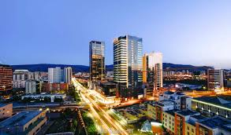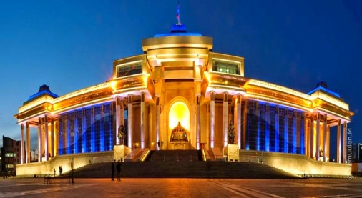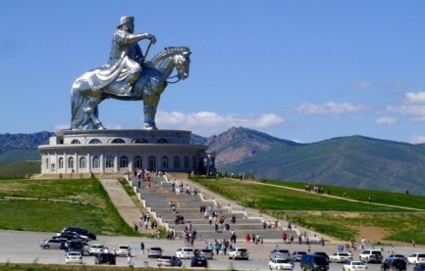

**SEE YOU IN ULAANBAATAR!**

Appendix 1

Application form for VIII International Conference of Students and Young Scientists “University Sport: Health and Prosperity of a Nation”

20 – 21 April 2018

|  |  |
| --- | --- |
| **Family name:** |  |
| **Name:** |  |
| **Second name (if available):** |  |
| **Country:** |  |
| **City:** |  |
| **University (full title):** |  |
| **Position:** |  |
| **Degree (if available):** |  |
| **Address with ZIP code:** |  |
| **Phone with country code:** |  |
| **Mobile phone:** |  |
| **E-mail:** |  |
| **Participation form:** | **oral presentation**  **poster**  **just publication in the Conference proceedings book** |
| **Necessity in booking hotel** |  |
| **Paper title:** |  |
| **Authors:** |  |