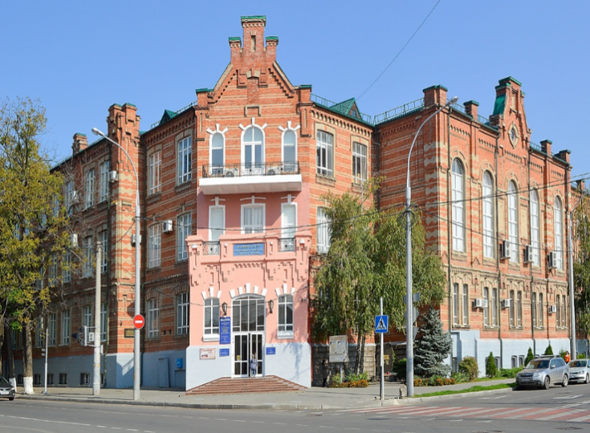
"Olympic Sport and Sport for All"
XXVIII International Scientific Congress
Krasnodar 2022

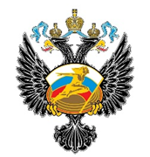 |  | 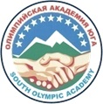 | 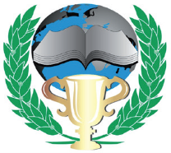

INFORMATION LETTER
XXVIII International Scientific Congress
Olympic Sport and Sport for All
6-7 October 2022

Dear colleagues!

We invite you to participate in the XXVIII International Scientific Congress "Olympic Sport and Sport for All", which will be held on October 6-7, 2022 in Krasnodar at of the Kuban State University of Physical Education, Sport and Tourism.

The purpose of the Congress is to consolidate scientists and specialists to discuss various problems of the modern Olympic movement, Olympic heritage, student sports, medical and biological support of Olympic sports, sports for all.

Representatives of the International University Sports Federation (FISU), National Olympic Committees, Russian and foreign scientists, specialists in the field of physical education and sports, sport medicine, physiology and biochemistry of sports, teachers, researchers, doctoral students and graduate students of higher educational institutions are invited to the Congress.

Scientific fields
Physical culture and sport Olympic education.
Modern Olympic movement: achievements, problems, risk factors.
Olympic legacy in the system of humanitarian education.
Medico-biological support in high performance sport.
Sports safety.
Sports for all in modern world.
Student sports in modern world: problems, perspectives.

Official languages of the Congress: Russian | English

Forms of participation
Correspondence: publication of an article
In-person: speaker (presentation of a report and publication of an article)
listener (participation in discussions with (without) publication of an article)

Application for participation
An application form and an article have to be sent to the e-mail: congress2022@kgufkst.ru (application form is attached).
The deadline is until August 5, 2022.
Within 10 days after receiving the application and materials, you will be informed about the inclusion in the composition of Congress participants.

Registration fee

The cost of participation in absentia is 850 ₽ (publication of an article, sending an electronic version of the collection of materials, an electronic version of the participant's certificate, posting materials of the Congress in the RSCI).

The cost for full time participation
№ | Category | Cost
1 | Students/Master students | 4225₽
2 | Postgraduate/Doctoral students | 5200₽
3 | Participants | 6500₽

The registration fee for full-time participation is paid for the publication of one article, posting an article in the RSCI database, participation in the work of the Congress, receiving materials of the Congress (a program, a collection of articles, a badge, a participant certificate, a notebook, a pen, coffee break, dinner). Registration fee is paid after the acceptance of the article.
Travel, accommodation and food expenses are paid by the participants or the sending party, unless otherwise provided by the organizational fee.

Registration fee payment
The registration fee can be paid by bank transfer. When making a bank transfer, you must indicate the purpose of the payment, full name and send a confirmation of payment to the email address: congress2022@kgufkst.ru
Organizing committee coordinates
Address: 350015, Krasnodar, st.Budyonny, 161, Kuban State University of Physical Education, Sport and Tourism (FSBEI HE KSUPhEST).
Website:https://kgufkst.ru/science/konferentsii-kongressy/xxviii-mezhdunarodnyy-nauchnyy-kongress/
Tel.: 8-988-46-02-154 Е-mail: congress2022@kgufkst.ru.
Contact person - Doctor of Biological Sciences, Professor I.N. Kalinina

Requirements for the design of materials for publication
General requirements. Conference materials in the form of an abstract must be completed using the software capabilities of Microsoft Word with the extension .doc (.docx), Times New Roman font, size 14, margins 2.0 cm on all sides, paragraph indentation - 1.25 cm (paragraph indentation using the "space" and "tab" keys is not allowed), spacing 1,15, text alignment by width. Sealing intervals is prohibited. The initials in the text and references are connected by a “non-breaking space” - I. I. Ivanov). The volume of materials is up to 5 pages of A4 format.
Line-by-line design of materials:
1. UDC (capital, left alignment, font size 14 pt);
2. Title of the article (capital letters, bold letters, center alignment, font size 14 pt) (in Russian and English);
3. Initials, Author's surname, academic degree, academic title, position (center alignment, font size 12 pt) (in Russian and English);
4. Organization name (in full), city and country (center alignment, font size 12 pt) (in Russian and English);
5. Annotation. It should be in Russian and English, include a description of the main topic, the scientific article issue, the purpose of the work and its results. The annotation indicates what is new in comparison with others related in subject matter and purpose. For English-speaking participants English variant is possible. The volume of the abstract is up to 120 words (italic font, justified alignment, font size 12 pt);
6. Keywords. Both single words and phrases in the singular and the nominative case, separated by a comma can be used as keywords. The recommended number of words is from 5 to 7 (italic font, alignment in width, font size 12 pt) (in Russian and English);
7. A list of references. References are obbligatory (from 5 to 7 sources), completed according to the GOST P7.0.5-2008, Times New Roman font, size 12 (an example of design is attached).
8. The text can include graphic images and tables in black and white, for which it is necessary to indicate their location in the article with links, for example - Fig. 1, Fig. 2, Table 1 in word format.
9. The originality of the text when analyzed in the Antiplagiarism system is at least 70%.
10. Responsibility for the quality of translation into English of separate parts of the article lies with the author of the publication, the use of automatic machine and online translators of texts is unacceptable.
11. Articles received by the Organizing Committee later than August 5, 2022 or those do not meet the above requirements will not be published.

Example of article design

UDC:ХХХ
UNIVERSITY OLYMPIC EDUCATION: CONTENT AND IMPLEMENTATION
I.I. Ivanov, Candidate of Pedagogical Sciences, Associate Professor
Federal State Budgetary Educational Institution of Higher Education "Kuban State University of Physical Education, Sports and Tourism", Krasnodar, Russia

Annotation (120 words).

Keywords (5-7 words).

Text (in width)
References:

Materials and an application for participation should be sent by e-mail in separate files named after the author's last name. For example: I.I. Ivanov. (materials) Krasnodar, I.I. Ivanov (application) Krasnodar.

Application form
XXVIII International Scientific Congress
"Olympic sport and sport for all"
Surname, name, patronymic (in full)
Title of the report
Academic degree, title
City, region (territory), country
Organization (full name)
Position (full name)
Mailing address
Contact phone numbers with code
E-mail
Form of participation (full-time, correspondence)
Form of speech (plenary report, section report, poster presentation, participation without a speech)
Field of the conference
Hotel reservation | Yes | No
Date and time of arrival
Date and time of departure
By submitting the report materials, I confirm my consent to the transfer of exclusive rights to their publication in the collection, with subsequent placement in the RSCI database (Yes / No)

