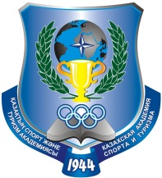 | MINISTRY OF EDUCATION AND SCIENCE OF THE REPUBLIC OF KAZAKHSTAN  INTERNATIONAL ASSOCIATION OF  PHYSICAL EDUCATION AND SPORT UNIVERSITIES  KAZAKH ACADEMY OF SPORT AND TOURISM | 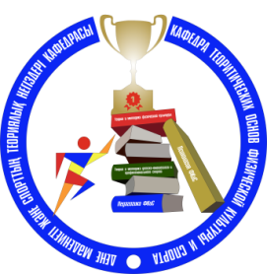
informational letter

Dear colleagues!

In connection with the emergence of the COVID-19 pandemic and quarantine activities in the Republic of Kazakhstan, the International Scientific and Practical Conference "INNOVATIONS IN EDUCATION, PHYSICAL EDUCATION, SPORT AND TOURISM" dedicated to the 75th anniversary of the victory in the Great Patriotic War, which will be held on April 24, 2020 in Almaty, on the basis of the Kazakh Academy of Sport and Tourism, is transferred to the virtual format.
All conference participants will receive certificates and the collection of papers in electronic form.
The deadline for submitting articles is extended until April 20, 2020. Articles are submitted to the organizing committee at tofkis_orgkomitet@mail.ru
Dear conference participants, in connection with the closure of bank branches due to quarantine in the Republic of Kazakhstan, residents of the Republic of Kazakhstan are offered an alternative registration fee options using the mobile application Kaspi.kz:
- Recipient Doshybekov Aidyn Bagdatovich, cell phone number: 8-707-150-37-32.
Please note in the message “Registration fee” when paying via the application Kaspi.kz.
The previously proposed payment details for paying the registration fee are relevant for foreign conference participants:
NCJSC «Kazakh Academy of Sport and Tourism»
BIN - 010840001890
Bank AGF JSC “BankCenterCredit”
BIC – KCJBKZKX
IIC (KZT) KZ 078 560 000 000 011 507
BC - 16
Address: Republic of Kazakhstan, 050022, Almaty, 85 Abay Ave.
Phone number: 292-07-56, accountant 292-37-36
e-mail: kazsport@inbox.ru

With regards, Conference Organizing Committee

Contact information of the organizing committee:
Doshybekov Aidyn Bagdatovich – cell phone 8-707-150-37-32
Ten Alina Vladimirovna – cell phone 8-775-99-400-80
Tukayeva Aray Bekbolatovna – cell phone 8-707-258-42-46

Reception of article:
Zhidovinova Anna Vyacheslavovna – cell phone 8-707-320-09-54
Belegova Aliya Akanbaevna – cell phone 8-701-322-88-52

